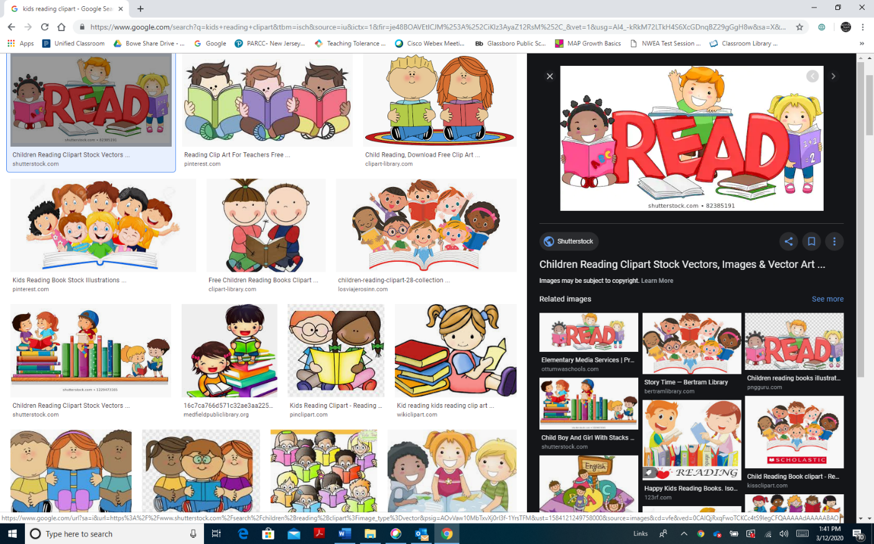
BSI HOME INSTRUCTION GUIDELINES
Greetings Parents ,
Attached are 4 ADDITIONAL resources your child will be utilizing due to school closure.
Your child should complete 2 assignments per week.
They are great practice for NJSLA test practice. If your have internet access, the commonlit.org, assignments are linked on my Google Classroom.
60 Days of Complimentary Service from Comcast https://www.internetessentials.com/covid19

If you have any questions, please feel free to contact me.
Have a great day!
Mrs. R. Seabroook-Hart
Basic Skills Teacher (Grades 4-6)
Thomas E. Bowe School
Email Address: rhart@gpsd.us

Google Classroom Codes 2019-2020
4th Grade :comj6sn
5th Grade: gyxryfm
6th Grade : qhxoy22
(r5232xm Fennimore B class)

