Mrs.NotDirty

**Your floor is very dirty, especially the commonly walked-on tile of your kitchen, bathroom, or if you are rich, garage.**

**Stop with the binge-watching commercials, Mrs.NotDirty is here to help.**

**Mrs.NotDirty kills 99.99% of bacteria, and if you do the math, 99.99% is greater than 99.9%, meaning Mr.Clean will stay mad.**

**Directions: Just don’t eat it**

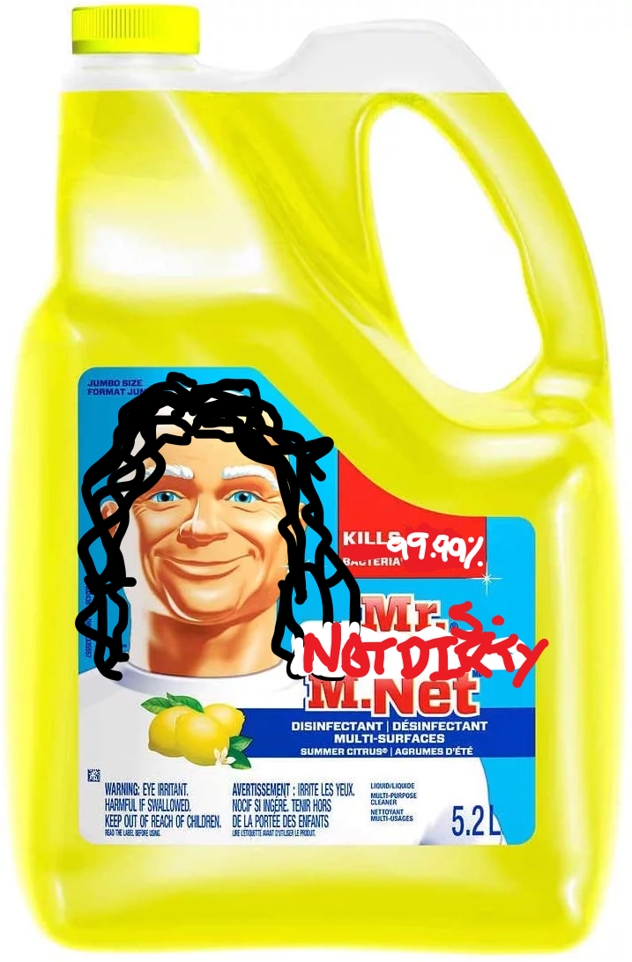

**Mr.s NotDirty! Mrs. NotDirty! Mrs. NotDirty!**