Glassboro High School
Performing Arts Academy
Serving students in grades 7-12


Application for
Admission
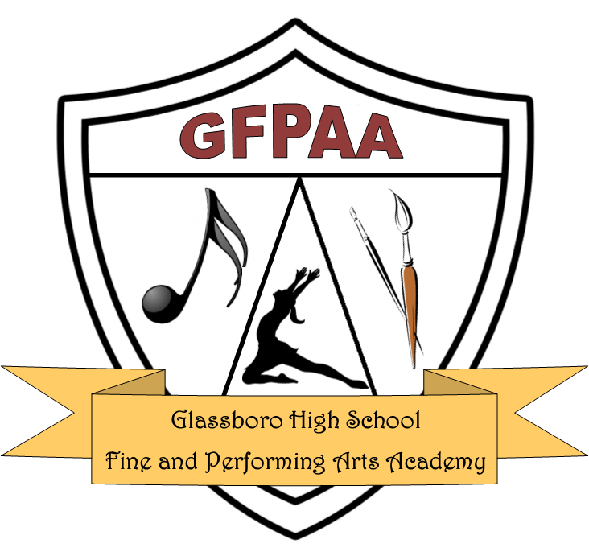
Established 2011

Glassboro High School
550 Joseph Bowe Blvd
Glassboro, New Jersey 08028
http://www.gpsd.us

Application Due Date: November 25, 2024

2025-2026 SCHOOL YEAR APPLCATION

Student and Parent/Guardian Information

Student’s Name: __________________________________ Current Grade Level: ______ DOB ____________________

Address: _________________________________________________ ___________ ________________
(Street) (City) (State) (Zip code)

Parent/Guardian: ___________________________________ Home Phone: _____________ Cell Phone: ______________

Parent/Guardian: ___________________________________ Home Phone: _____________ Cell Phone: ______________

Parent Email ______________________________________ Student Email ______________________________________

X______________________________________ __________________
Parent/Guardian Signature Date

The above signed gives permission for the release of all above applicant’s school records to Glassboro Public School

Musical Area of Specialty (The type of study for which you are applying) – check only one
Instrumental Music ____ Vocal Music ____ Music Technology ____

Instrumentalists Information
If you selected Instrumental Music, indicate the instrument you wish to audition and study: _________________________

For how many years have you been playing this instrument? ____

If you have studied privately with a teacher (outside of school), please share the number of years and list the teacher/s:
___________________________________________________________________________________________________
___________________________________________________________________________________________________

Identify any musical honors you have received, including awards, recognition, participation in honors ensembles, etc.. Provide the year as well for each item:
___________________________________________________________________________________________________
___________________________________________________________________________________________________
___________________________________________________________________________________________________

Identify the instrumental ensembles in which you have participated in school or in your community, not including honors ensembles named above.
___________________________________________________________________________________________________
___________________________________________________________________________________________________
List any other instruments you currently play: ______________________________________________________________
___________________________________________________________________________________________________

If you have also had experiences in choral music ensembles and/or musical theater, please identify them :
___________________________________________________________________________________________________
___________________________________________________________________________________________________
___________________________________________________________________________________________________

Identify any non-performance music courses or classes you have taken (eg. Music Theory, Music Tech):
____________________________________________________________________________________________________
____________________________________________________________________________________________________

Vocal Music Information

For how many years have you been studying vocal music? ____

Describe your vocal range: ____________________________________________________________________________

If you have studied privately with a teacher (outside of school), please share the number of years and list the teacher/s:
___________________________________________________________________________________________________
___________________________________________________________________________________________________

Identify any musical honors you have received, including awards, recognition, participation in honors ensembles, etc.. Provide the year as well for each item:
___________________________________________________________________________________________________
___________________________________________________________________________________________________
___________________________________________________________________________________________________

Identify the choral ensembles in which you have participated in school or in your community, not including honors ensembles named above.
___________________________________________________________________________________________________
___________________________________________________________________________________________________
List any instruments you currently play: ______________________________________________________________
___________________________________________________________________________________________________

If you have also had experiences in instrumental ensembles, please identify them:
___________________________________________________________________________________________________
___________________________________________________________________________________________________

Identify any experiences you have had with musical theater as a performer (list any shows and roles):
___________________________________________________________________________________________________
___________________________________________________________________________________________________

Identify any non-performance music courses or classes you have taken (eg. Music Theory, Music Tech):
____________________________________________________________________________________________________

Music Technology Information

If you are an instrumentalist and/or vocalist, please complete the respective portions for these areas above, as well as the music technology information below.

Describe your experiences with Music Technology. Include such information as your experiences with recording equipment/software, types of equipment/software used, projects created, courses taken in school or outside of school.
__________________________________________________________________________________
__________________________________________________________________________________
__________________________________________________________________________________
__________________________________________________________________________________
__________________________________________________________________________________
__________________________________________________________________________________
__________________________________________________________________________________

In which areas of Music Technology are you interested?
__ sound recording, sound engineering
__ composition and performance
__ other – describe __________________________________________________________________________________

School Contact Information and Performance

Information for school and school district presently attending
Name of School: __________________________________________ School District: ________________________________

Address: _________________________________________________ ___________ ________________
(Street) (City) (State) (Zip code)

Contact Person at your school district: ______________________________ Phone: ____________________

As members of the Glassboro Music Academy, students are also enrolled in academic classes and are expected to maintain their grades. Students must be able to balance the demands of classwork with the preparations for music lessons, music ensembles and other activities. The following documents are required for the application to be considered complete. Please attach these documents. Someone at your school will be able to assist you with obtaining this information.

_______ previous year’s final report card

_______ previous year’s Standardized Test Score report (must show scores for ELA and Math). Can also include previous year’s scores.

_______ Current MP 1 grades

_______ copy of student attendance record

_______ copy of student discipline record

Upon receipt of applications and other documents an audition will be scheduled. The audition will include your solo performance, scales, a short ear-training assessment, sight-reading, a general music knowledge assessment and an interview.

Personal Statement Form
Directions: Use the space below to write, or type, your responses to the prompts. In paragraph form, use this space to share a little more about your background and why you would like to be a part of the Glassboro Music Academy.

__________________________________________________________________________________
__________________________________________________________________________________
__________________________________________________________________________________
__________________________________________________________________________________
__________________________________________________________________________________
__________________________________________________________________________________
__________________________________________________________________________________
__________________________________________________________________________________
__________________________________________________________________________________
__________________________________________________________________________________
__________________________________________________________________________________
__________________________________________________________________________________
__________________________________________________________________________________
__________________________________________________________________________________
__________________________________________________________________________________
__________________________________________________________________________________
__________________________________________________________________________________
__________________________________________________________________________________
__________________________________________________________________________________
__________________________________________________________________________________
__________________________________________________________________________________
__________________________________________________________________________________
__________________________________________________________________________________
__________________________________________________________________________________
__________________________________________________________________________________
__________________________________________________________________________________
__________________________________________________________________________________
__________________________________________________________________________________
__________________________________________________________________________________
__________________________________________________________________________________
__________________________________________________________________________________
__________________________________________________________________________________
__________________________________________________________________________________
__________________________________________________________________________________
__________________________________________________________________________________
__________________________________________________________________________________
__________________________________________________________________________________
__________________________________________________________________________________
__________________________________________________________________________________

